**Unit 3: Developmental Psychology (7-9% of AP Exam)**

**SSPBC3: Describe behavioral, social, and cognitive changes from the prenatal period throughout the life span.**

a. Chart physical changes of a human being from conception through late adulthood.

b. Explain the developmental models of Freud, Piaget, Kholberg, and Erikson.

c. Compare and contrast the theories of language and language acquisition: include Chomsky, Skinner, and Whorf.

d. Describe the role of critical periods in development.

|  |  |  |  |
| --- | --- | --- | --- |
|  | Define | Advantages | Disadvantages |
| Cross-Sectional  Design | *See Below* |  | *(Cohort effect; see below)* |
| Longitudinal  Design | *See Below* |  |  |
| Cohort Effect: The effect that having been born in a certain time, region, period or having experienced the same life experience (in the same time period) has on the development or perceptions of a particular group. These perceptions, characteristics or effects are unique to the group in question. | | | |

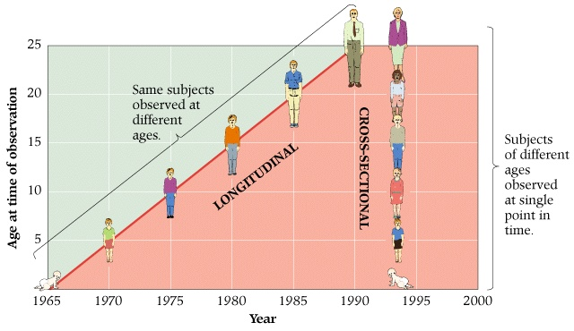

|  |  |
| --- | --- |
| **Prenatal Developmental Stages (ZEF)** | |
| Zygote |  |
| Embryo |  |
| Fetus |  |

|  |  |  |  |
| --- | --- | --- | --- |
| **Problems with Development** | | | |
| Teratogens |  | | |
| Fetal Alcohol Syndrome |  | | |
| **Type of Innate Reflexes** | | | |
| Rooting Reflex | |  | |
| Gripping Reflex | |  | |
| Moro Reflex | |  | |
| **Types of Temperament** | | | |
| Easy Children | | |  |
| Slow-To-Warm-Up Children | | |  |
| Difficult Children | | |  |

|  |
| --- |
| **Habituation** |
|  |

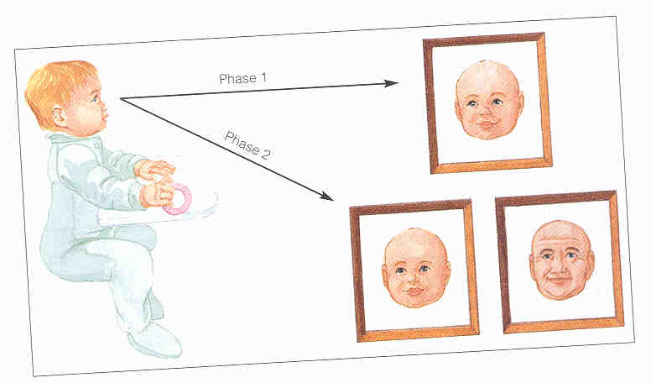

Sensory Adaptation: When receptors **stop** responding to stimuli; messages are not sent to the brain. (*physiological*)

Habituation: Receptors receive information and send to the brain, but the signals are **blocked** from the cortex. (*psychological*)

|  |  |
| --- | --- |
| **Physical Development** | |
| Maturation |  |
| Neural Networks Develop: *The brain and its many connections develop at exponential rates early in life. Higher rates of neural networks are correlated with higher levels of nurturing in the first months.* | |
| Synaptic Pruning |  |

|  |  |
| --- | --- |
| **Physical Development** | |
| Cephalocaudal trend |  |
| Proximodistal trend |  |

|  |  |  |  |
| --- | --- | --- | --- |
| **Jean Piaget and Cognitive Development Key Terms** | | | |
| Schema | |  | |
| Assimilation | |  | |
| Accommodation | |  | |
| **Piaget’s Stages of Cognitive Development (Some People Can Fly)** | | | |
| Stage | Ages | | Milestones |
| **Sensorimotor** |  | | Define: |
| Object Permanence (characteristic and mastered): |
| **Preoperational**  (*representing things with words and images but lacking logical and scientific reasoning*) |  | | Symbolic play (characteristics): |
| Egocentrism (characteristic): |
| Animism (characteristic): |
| Artificialism (characteristic): an assumption that conscious entities make and are responsible for anything that exists *(everything in existence was made by humans or a higher power, i.e. trees, lakes, animals, etc.)* |
| **Concrete Operational**  (*gain the mental operations that enable them to think logically about actual ( or concrete) events*) |  | | Conservation (lacking in preoperational, mastered in concrete):  *(Children master conservation of mass, volume, area and number)* |
| Reversibility (mastered): |
| Centration (mastered, called Decentration):  *(i.e. Preoperational children think in one-dimension: cannot compare short and fat to tall and thin simultaneously. Concrete are more 2-dimensional.)* |
| **Formal Operational** |  | | Main characteristics: |

|  |  |
| --- | --- |
| **Lev Vygotsky’s Social-Cultural Development** | |
| Define | Cognitive development is fueled by **social interactions** with parents, teachers and other children. (*i.e. culture and language shape cognitive growth*) |
| Zone of Proximal Development (ZPD) | Example on next page |

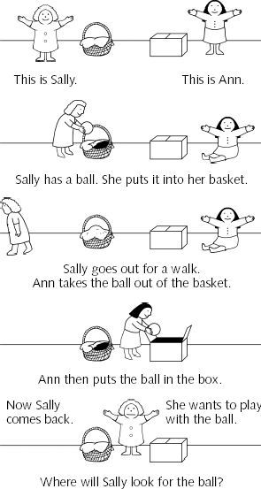



____________________________________

Theory of Mind (at right)

Theory of mind is the ability to attribute mental states — beliefs, intents, desires, pretending, knowledge, etc. — to oneself and others and to understand that others have beliefs, desires, intentions, and perspectives that are **different** from one's own.

Attachment: ____________________________________________________________________________________________________________________________________________________________________________________________________

|  |
| --- |
| **Harry Harlow’s Experiment with Attachment (Rhesus Monkeys)** |
|  |

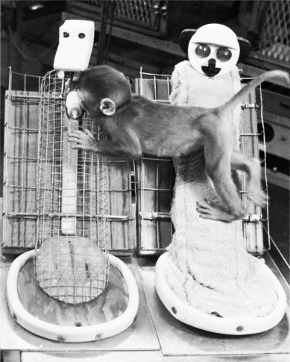

Wire mother; with food

Cloth mother; no food

|  |  |  |  |
| --- | --- | --- | --- |
| **Mary Ainsworth’s Patterns of Attachment** | | | |
| “The Strange Situation” | *In this infants are exposed to series of eight separation and reunion episodes to assess the quality of attachment.* (***separation anxiety***) | | |
|  | When Mother Leaves: | Interaction with Caregiver: | When Mother Returned: |
| Secure Attachment |  |  |  |
|  | When Mother Leaves: | Interaction with Caregiver: | When Mother Returned: |
| Insecure attachment:  anxious |  |  |  |
| Insecure attachment:  avoidant |  |  |  |
| Insecure attachment:  disorganized | N/A | N/A |  |

|  |  |
| --- | --- |
| **Konrad Lorenz** | |
| Imprinting and Familiarity | Impact of a **Critical Period** on Imprinting |
|  | A period during someone's development in which a particular skill or characteristic is believed to be most readily acquired. (Lorenz’ geese had 13-16 hour critical period after hatching.) |

|  |  |  |  |  |  |  |  |  |
| --- | --- | --- | --- | --- | --- | --- | --- | --- |
| **Diana Baumrind and Parenting Styles** | | | | | | | | |
| Parenting Styles | | | Description of Parenting Style | | | | | Children Tend to Be… |
| Authoritarian | | |  | | | | |  |
| Permissive | | |  | | | | |  |
| Authoritative | | |  | | | | |  |
| **Freud’s Psychosexual Development (Focuses on the Libido: Sexual Energy)** | | | | | | | | |
| Stage | Ages | | | Erogenous Zone | | Consequences of Fixation | | |
| Oral |  | | |  | |  | | |
| Anal |  | | |  | |  | | |
| Phallic |  | | |  | |  | | |
| Latency |  | | |  | |  | | |
| Genital |  | | |  | |  | | |
| **Erik Erikson’s Psychosocial Development (Neo-Freudian)** | | | | | | | | |
| Conflict | | Ages/Period | | | Example of the Conflict | | Positive Resolution | |
| Trust v. Mistrust | |  | | |  | | *Sense of security* | |
| Autonomy v. Shame and Doubt | |  | | |  | | *Sense of independence* | |
| Initiative v. Guilt | |  | | |  | | *Balance between spontaneity and restraint* | |
| Industry v. Inferiority | |  | | |  | | *Sense of self-confidence* | |
| Identity v. Role Confusion | |  | | |  | | *Unified sense of self* | |
| Intimacy v. Isolation | |  | | |  | | *Form close personal relationships* | |
| Generativity v. Stagnation | |  | | |  | | *Promote well-being of others* | |
| Integrity v. Despair | |  | | |  | | *Sense of satisfaction with life well lived* | |

|  |  |
| --- | --- |
| **Types of Conflict** | |
| Approach-Approach |  |
| Approach-Avoidance |  |
| Avoidance-Avoidance |  |
| Multiple approach-approach |  |

|  |  |
| --- | --- |
| **Lawrence Kohlberg’s Levels of Morality (6 Stages)** | |
| Preconventional |  |
| Conventional |  |
| Postconventional |  |

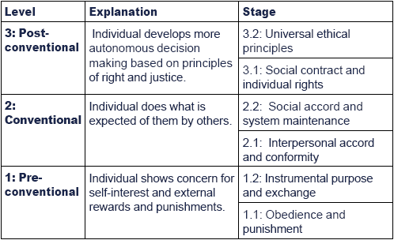

|  |  |
| --- | --- |
| **Summarize the differences in morality based on sex/gender according to Carol Gilligan** | |
| Men (Kohlberg) base morality on: | Women (Gilligan) base morality on: |
| 1. logic  2. individualism  3. protecting the rights of those individuals  4. upholding of justice | Androgyny is the best way to realize one’s potential as a human being. |

|  |  |
| --- | --- |
| **Physical Changes in Adolescence** | |
| Adolescence |  |
| Primary Sex Characteristics |  |
| Secondary Sex Characteristics |  |

|  |  |  |
| --- | --- | --- |
| **Cognitive Changes in Adolescence** | | |
| Most cognitive change occurs in the *prefrontal cortex*; the last part of the brain to fully mature. The PFC is crucial to high-level cognitive functions such as planning, organizing and response inhibition. | | |
| David Elkind’s “personal fable” | |  |
| Consequences of personal fables | | Consequence: |
| Consequence: |
| **Developmental Tasks of Early Adulthood (David Havighurst)** | | |
| 1 |  | |
| 2 |  | |
| 3 |  | |
| 4 |  | |
| 5 |  | |
| 6 |  | |
| 7 |  | |
| 8 |  | |

|  |  |
| --- | --- |
| **Daniel Levinson’s “Life Structure”: Four Seasonal Cycles** | |
| Preadulthood |  |
| Early adulthood |  |
| Middle adulthood |  |
| Late adulthood |  |

|  |  |  |  |
| --- | --- | --- | --- |
| **Marriage and Divorce** | | | |
| What are the current divorce rates in the US? | |  | |
| What age group is most likely to divorce? | |  | |
| Should couples  cohabitate before marriage? Explain. | |  | |
| Describe the  empty-nest syndrome and its impact on a marriage | |  | |
| **Cognitive Changes in Adulthood** | | | |
| Type of Intelligence | Define | | What Happens to it as we age? |
| **Fluid Intelligence** |  | |  |
| **Crystallized Intelligence** |  | |  |

|  |  |
| --- | --- |
| **The Five Stages of Dying (Elisabeth Kubler-Ross)** | |
| Denial |  |
| Anger |  |
| Bargaining |  |
| Depression |  |
| Acceptance |  |