Pre-Columbian America

THE RISE AND FALL OF THE OLMECS
Geographical Location | - Along __________ Coast of _______________
Environmental Conditions | 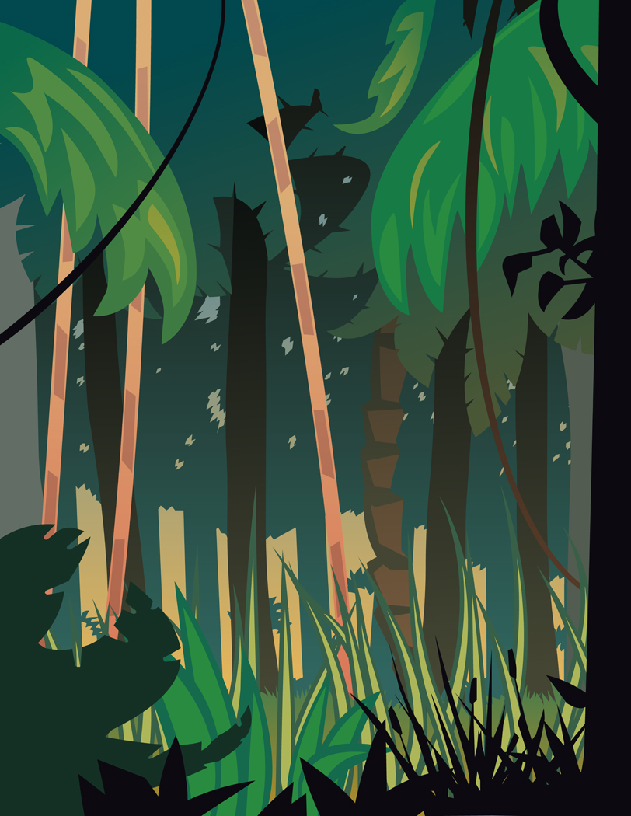  Covered with _____________ & _______________________  - _________________________ climate
Rise –  When & Why? | - Emerged around _______________  - Thrived between _____________________  - Fertile ___________ plains, abundant ___________________
Urban Design | - Combined _________________, plazas, and giant structures
Economy & Trade | - ____________________________________ in Mesoamerica
Social Structure | 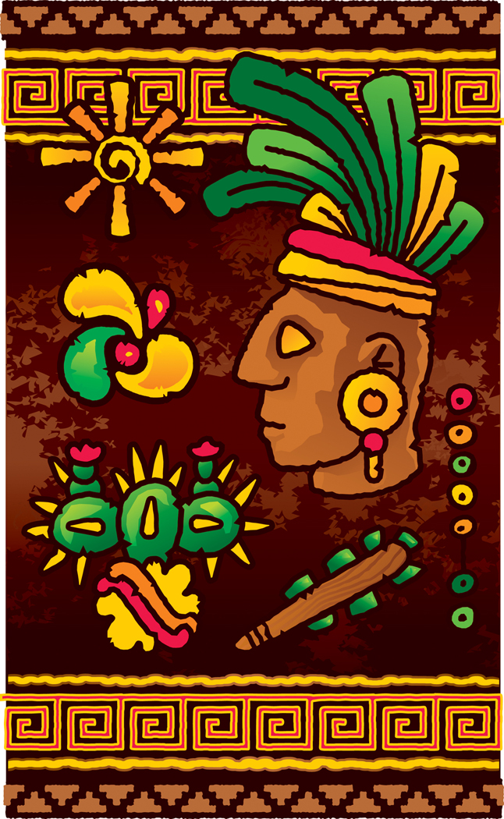  - _____________ class  - _____________ gods  - Worshipped ________________ spirit
Reasons for Decline | - _______________________
Legacy | - “____________________________________”  - First known ______________________________________ in Mesoamerica

THE RISE AND FALL OF THE …
 | Mayans | Aztecs | Incas
Geographic Location | - _________________ Peninsula | - _________________ Mexico | - __________ Mountain region
Environmental Conditions | - ____________ forests  - Dense ____________ | - Shallow ___________  - Fertile ____________ | - _________________
Rise | - Emerged ~ _______  - Thrived ___________ | - Emerged ~ _______  - Thrived ___________ | - Emerged ~ _______  - Thrived ___________
Traits | - __________________ important  - __________________  - Independent _______ ____________  - _________________ agriculture | - __________________ important  - __________________  - Powerful __________  - Empire of ______________ states | - __________________ important  - __________________  - Major __________ systems  - Huge __________________
Why did civilization rise? | - ____________ culture  - Loyal to __________  - Wealthy & prosperous _______________  - Able to ___________ ____________ to feed larger population | - ____________ culture  - Loyal to __________  - Used prisoners for religious _________________  - Adding of lands provided __________ | - ____________ culture  - Loyal to __________  - Entire empire was _________________
Reasons for Decline | - Many resources used for _______________ activities  - Frequent __________  - Population _________ | - Many resources used for _______________ activities  - Warfare became less _______________ | - Many resources used for _______________ activities  - Enemies used ___________ system

CULTURE
 | Mayans | Aztecs | Incas
Government | - ______________ city-states, each ruled by a ______________ | - Small ____________  - Divided in _______ provinces | - _____________  - __________________
Economy | - Based on _________ & ________________ | - Made conquered areas pay _________  - Trade connected by ____________ | - __________ controlled most economic activity
Religion | - _________________  - _________________ _________________ | - _________________  - _________________ _________________ | - _________________  - _________________  - _________________
Social Structure | - ____________  - _____________  - ______________  - _________________ | - ________________  - _____________  - ______________  - _________________ | - _________________ cooperation  - _________________  - Single, uniform ________________
Technology | - _________________  - Math = ___________  - _________________  - _________________ | - _________________  - _________________  - _________________ | - __________________
The Arts | - _________________  - _________________  - _________________ | - Elaborate _________  - _________________  - __________________  - _____________ | - __________________ __________________  - _____________

