Ch. 1: Thinking Critically with Psychological Science
Nearpod Code – K L J T D
SSPFR2: The student will explain the research methods and the types of statistics used in the field of psychology.
a. Explain how psychologists conduct research to describe, explain, predict, and control behavior.
b. Describe the types of research methods used by psychologists: include experiment, survey, case study, and observation.
c. Identify the basic elements of an experiment: include independent and dependent variables, types of experimental control (blind/double-blind procedures, placebo controls).
d. Explain the differences between a correlation and an experiment.
e. Classify the types and uses of statistics in psychological research; include descriptive statistics and inferential statistics.
f. Interpret graphic data representations.
g. Explain ethical issues in psychological research.
Name, Event or Concept | Leading Questions
The Need For Psychology  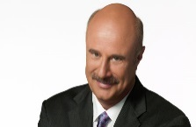  Dr. Phil McGraw  How Should We Conduct  A Job Interview? | 1. How would you define “common sense?”  2. Is there a problem with simply relying on common sense all the time to make our decisions?  3, What is a simple two-word definition of “intuition?”
Common Problems of  Common Sense  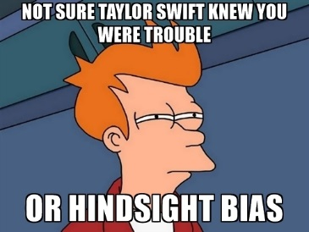  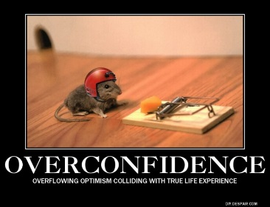 | 1. What is “Hindsight Bias?”  2. What are the three levels of Hindsight Bias?  a.  b.  c.  3. What is “overconfidence?”
The Scientific Mind  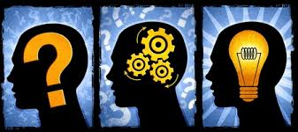  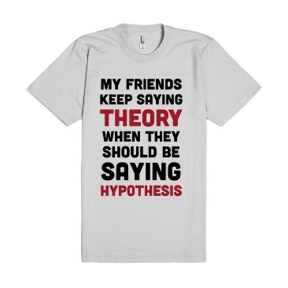  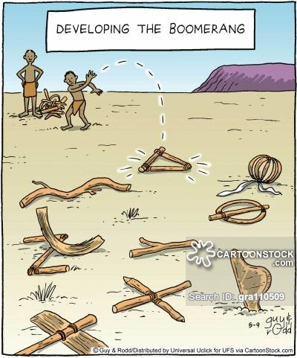  Boomerang Research | 1. What are the three components of the Scientific Attitude?  a.  b.  c.  2. What are four aspects of “Critical Thinking?”  a. b.  c. d.  3. Why do psychologists use the Scientific Method?  4. What is a Theory?  5. What is a Hypothesis?  6. Summary: A hypothesis is a theory that has been redesigned in a way that  _________ ______ __________________.  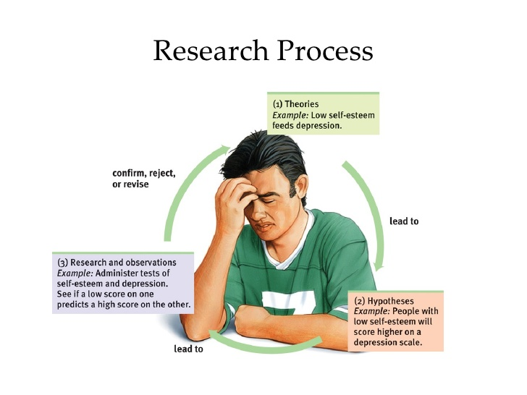
Descriptive Research  Methods  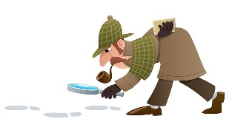  Case Study  Clinical Study  Naturalistic Observation  Descriptive Research Methods (continued)  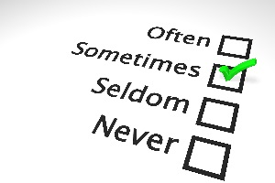  Survey  Wording Effect  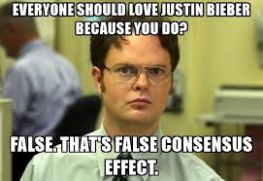  False Consensus Effect  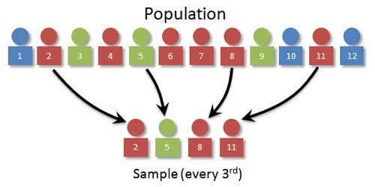  Random Sampling | 1. Define / describe the following Research Methods often used in Psychology.  a. Case Study -  b. Clinical Study -  c. Naturalistic Observation -  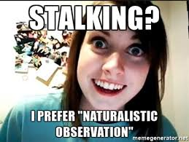  d. Survey -  2. How is a survey done?  3. What is the danger of the “Wording Effect” when conducting a survey?  4. Give an example of what choice of words might cause this.  5. What is the “False Consensus Effect?”  6. What is Random Sampling and why is it so important in a survey?
Correlation  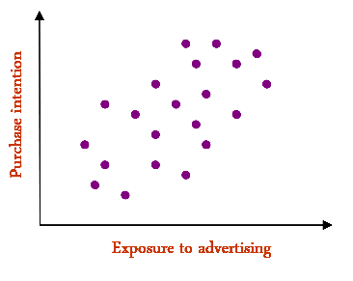Positive Correlation  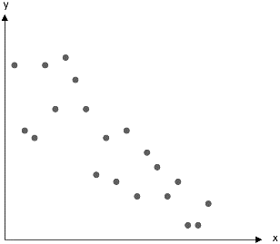  Negative Correlation | 1. What is a “correlation?”  2. What is a “correlation coefficient?”  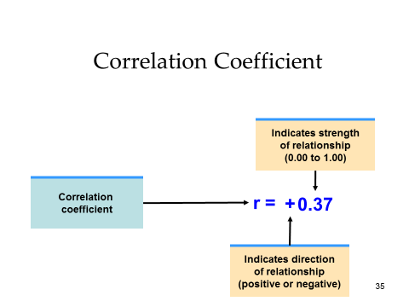
Scatterplots  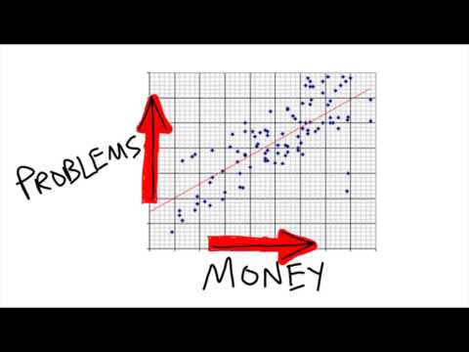  More Money = More Problems  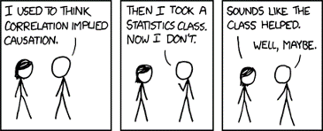  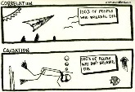 | 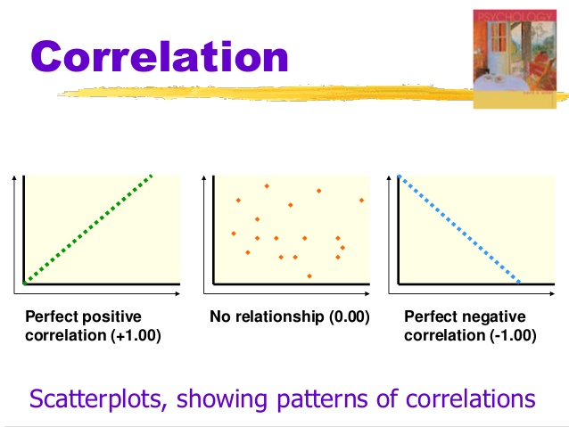  Always Remember  Correlation IS NOT Causation  1. What is an “illusory correlation?”
Finding Patterns  Where None Exist  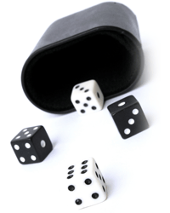 | Perceiving Order In Random Events  1. If you were randomly dealt five cards, which of the two possibilities below would you be less likely to get. Circle your choice?  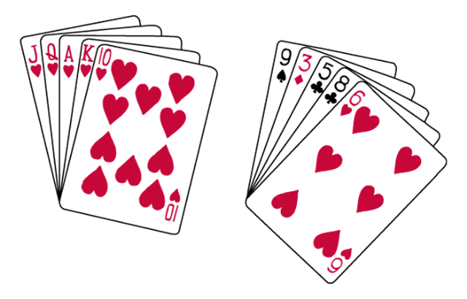  2. Why did you answer the way you did?
Experiment  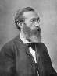  Wilhelm Wundt  remember him?  Experiment  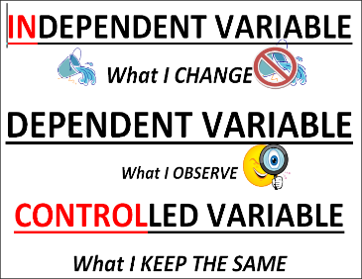  Know Your Variables  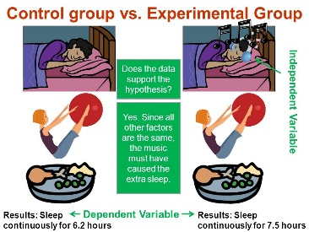  Experimental vs.  Control Group | Cause & Effect  1. What is the only research method to use if you are trying to find cause and effect?  2. What is an “independent variable?”  2. What is a “dependent variable?”  3. If neither the person conducting the experiment nor the people in the experiment know who is receiving the real treatment or a placebo, this is called a…  4. What is a “placebo?”  5. What is the “experimental group?”  6. What is the “control Group?”  Important  Random Assignment is critical when creating the control group and experimental group.
Research Summary  Describing Data | 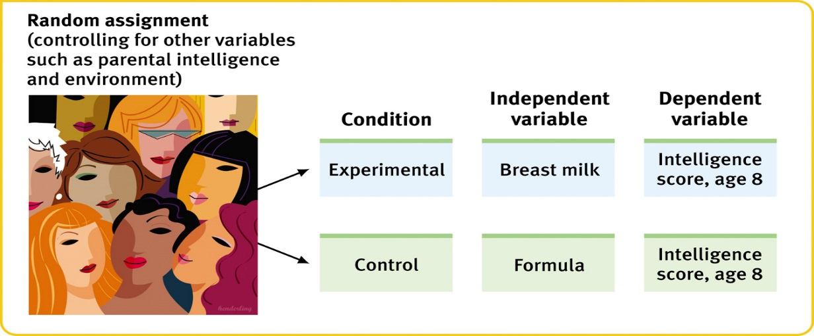  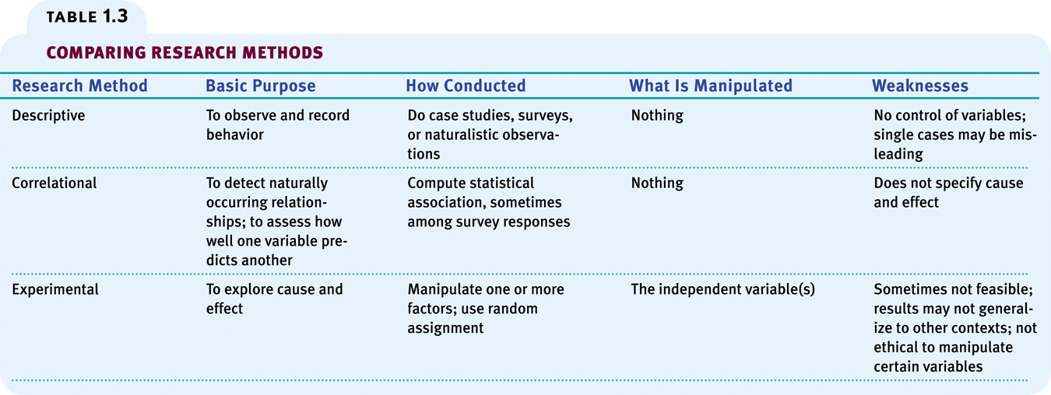  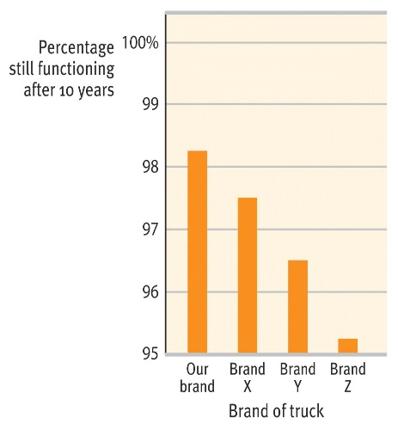 is the same as 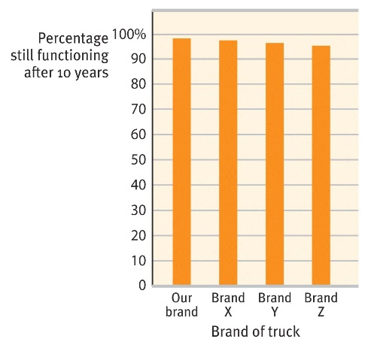
Statistics  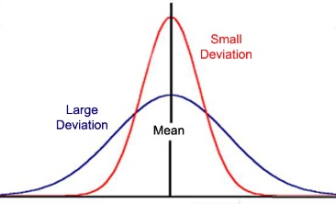 | Measures of Central Tendency  1. What is “mode?”  2. What is “mean?”  3. What is “median?”  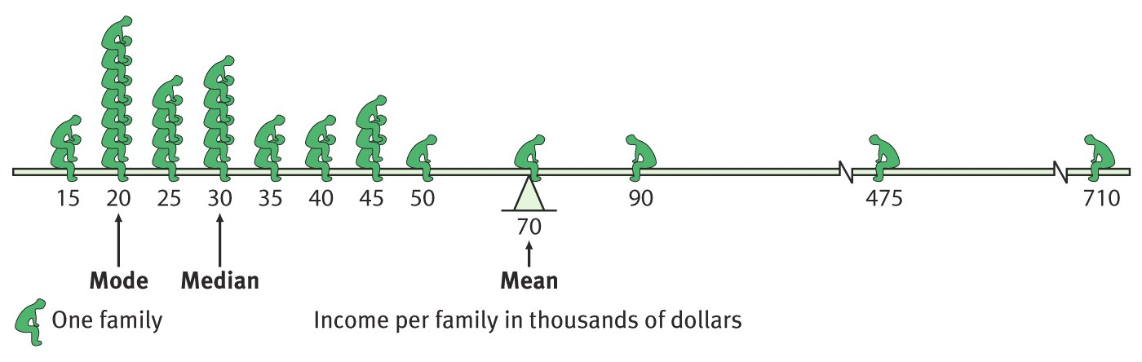  Measures of Variance  4. What does “range” mean?  5. What is “standard deviation?”  Remember  1. Representative samples are better than biased samples.  2. Less variable observations are more reliable than more variable ones.  3. More cases are better than fewer cases.

