The Cold War Begins
Nearpod Code - ZMLWX
SSUSH20 The student will analyze the domestic and international impact of the Cold War on the United States.
a. Describe the creation of the Marshall Plan, U.S. commitment to Europe, the Truman Doctrine, and the origins and implications of the containment policy.
b. Explain the impact of the new communist regime in China and the outbreak of the Korean War and how these events contributed to the rise of Senator Joseph McCarthy.
Person, Event or Concept | Leading Questions
Origins of the Cold War  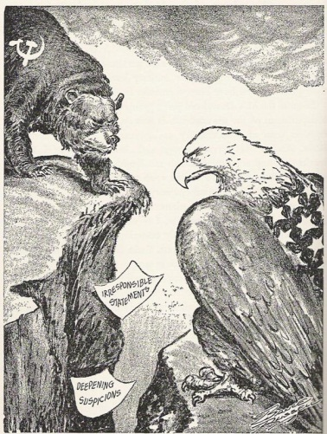 | 1. On what issue did US President Truman and Soviet leader Stalin disagree following WWII?  2. How did the Soviet Union and the US differ economically?  3. What did Stalin and the Soviet Army do to most of Eastern Europe?  4. This rivalry led to a period of conflict known as what?  5. Which British leader agreed with Truman that Stalin was attempting to spread Soviet influence throughout the world?  6. What did Churchill mean when he said that Europe was divided by an “iron curtain”?
The Truman Doctrine (1947)  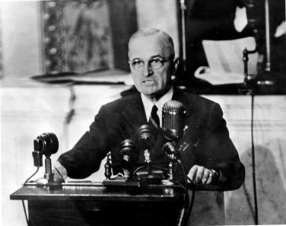 | 1. Why did the Soviet Union target the countries of Greece and Turkey in their attempt to spread communism?  2. Why did President Truman ask Congress to financially assist Greece and Turkey in their time of need?  3. Truman’s promise to help struggling nations from succumbing to communism was given what name?
The Containment Policy | 1. Who is George Keenan?  2. What did Keenan have to say about the Soviet Union?  3. Keenan’s argument led to the American policy of containment. What was containment?
The Marshall Plan | 1. What impact did WWII have on many European countries?  2. What was the Marshall Plan?  3. What effect did the Marshall Plan have on US/European relations?
Communist Take Over China  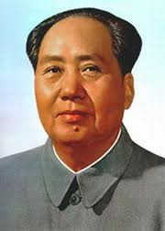 | 1. In 1949, who took over China?  2. As a result of his victory in the Chinese civil war, what changes did Mao Zedong make to the Chinese government?  3. Why is the Communist victory in China considered a failure of the containment policy?
The Korean War | 1. What political effect did WWII have on the Korean peninsula?  2. Who controlled North Korea?  3. Who controlled South Korea?  4. In 1950, North Korea (using Soviet supplied weapons) invaded South Korea by crossing which line of latitude?  5. How did President Truman react to the North Korean invasion?  6. When the US pushed North Korean forces back over the 38th parallel, what actions did China take?  7. What territorial changes occurred as a result of the Korean War?  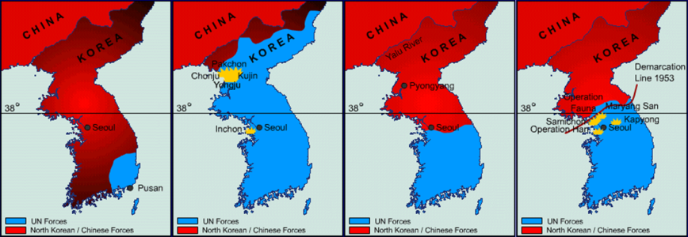
The Domestic Impact of the Cold War  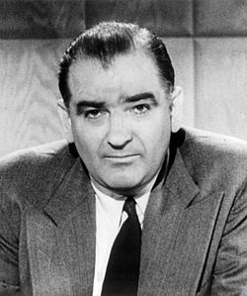 | 1. What impact did the events in China and Korea have on the American public?  2. Why did Congress create HUAC (the House Un-American Activities Committee)?  3. Why were Julius and Ethel Rosenberg executed in 1953?  4. In 1950, what accusations did Senator Joseph McCarthy (left) make concerning members of the US State Department?  5. What international events increased the popularity of Joseph McCarthy?  6. His quest to rid the government of communists was given what name?

