The Modern Era (1968-1992)
Nearpod Code - IDGAO
SSUSH25 The student will describe changes in national politics since 1968.
a. Describe President Richard M. Nixon’s opening of China, his resignation due to the Watergate scandal, changing attitudes toward government, and the Presidency of Gerald Ford.
b. Explain the impact of Supreme Court decisions on ideas about civil liberties and civil rights; include such decisions as Roe v. Wade (1973) and the Bakke decision on affirmative action.
c. Explain the Carter administration’s efforts in the Middle East; include the Camp David Accords, his response to the 1979 Iranian Revolution, and the Iranian hostage crisis.
d. Describe domestic and international events of Ronald Reagan’s presidency; include Reaganomics, the Iran-contra scandal, and the collapse of the Soviet Union.
Name, Event or Concept | Leading Questions
Richard Nixon  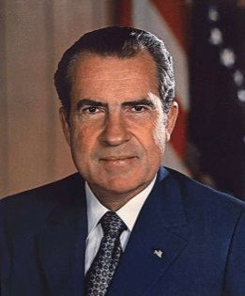 | 1. When was Richard Nixon elected President?  2. What does a conservative believe?  3. Why do many believe the election of Richard Nixon signaled the start of the conservative movement?  4. What milestone did Nixon reach concerning US relations with China?  5. What did Nixon’s visit to communist China have on the American economy?
The Watergate Scandal  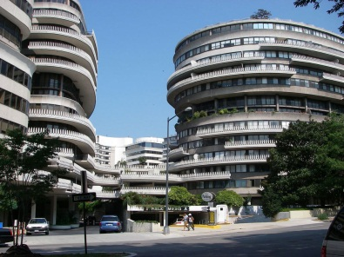  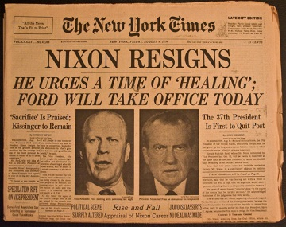 | 1. In 1972, why was Nixon worried about his chances for reelection?  2. What happened to some of Nixon’s campaign workers at the Democratic National Headquarters at the Watergate complex in Washington, D.C.?  3. What were these campaign workers looking for at the DNC headquarters?  4. What did the Nixon do in response to the Watergate break-in?  5. How did Congress respond to the Watergate break-in?  6. On what charge did Congress find Nixon guilty?  7. What two reasons prompted Nixon to resign from office?  a.  b.  8. What was unique about Nixon’s stepping down from the Presidency?  9. How did the Watergate scandal affect American trust in their government?
The Presidency of Gerald Ford | 1. Who took over as president after Nixon’s resignation?  2. Ford oversaw America during a time of severe economic recession. What is a recession?  3. What controversial decision did he make regarding President Nixon?
Supreme Court decisions of the 1970’s | 1. What right was granted after the decision in Roe v. Wade?  2 In Bakke v. Regents of the University of California what issue was brought before the Supreme Court?  3. What is affirmative action?  4. What did the Supreme Court say about the constitutionality of affirmative action in college acceptances in the Bakke decision?  1.  2.
Jimmy Carter  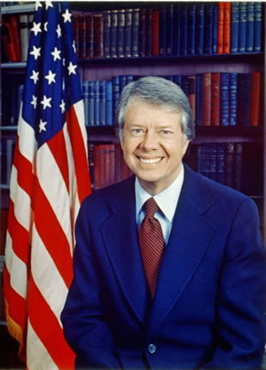 | 1. In 1976 who defeated Gerald Ford for the presidency?  2. What were the Camp David Accords?  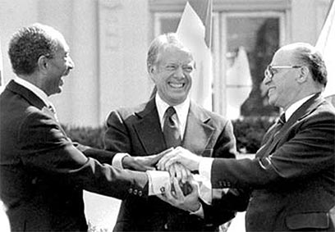  3. Why were the Camp David Accords significant?  4. Over what issue did the nations of the Middle East mainly argue?  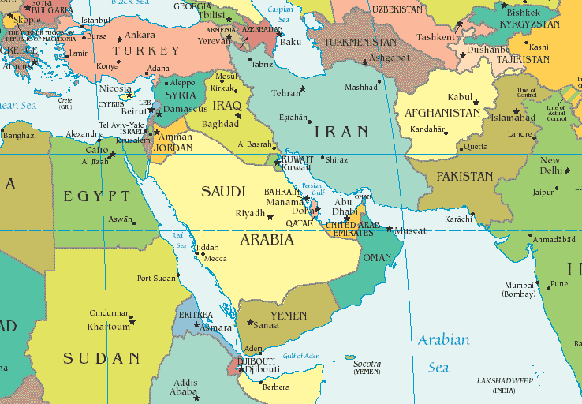
Iranian Revolution  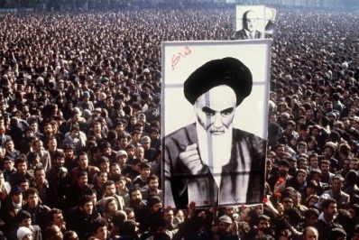 | 1. Through much of the 20th century, what Middle Eastern country had been an ally to the United States?  2. What is a “shah”?  3. What happened to the Iranian shah in 1979 while he was out of the country seeking medical attention in the US?  4. By whom did these Iranian Revolutionaries want to be ruled?
Iranian Hostage Crisis  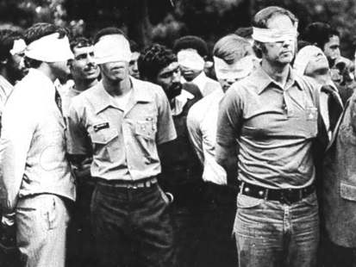 | 1. Muslim Revolutionaries were demanding the shah be returned to Iran from the United States. How did President Carter respond?  2. How did Muslim Revolutionaries respond to Carter’s refusal to send the Shah back to Iran?  3. How many American citizens were held hostage in Iran?  4. How long was their captivity?  5. When and why were the hostages finally released?  6. What did the Iran Hostage Crisis do to American-Middle Eastern relations?
Ronald Reagan  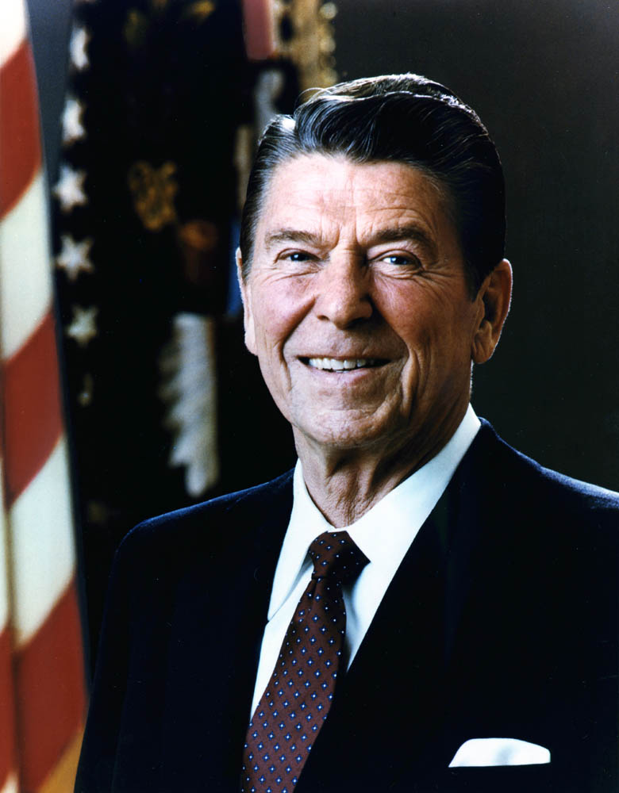 | 1. Who defeated Jimmy Carter for President in 1980?  2. As a conservative, what did Ronald Reagan believe concerning the role of government?  3. What was Regan’s economic plan nicknamed?  4. What two specific policies were included in Reaganomics?  a.  b.  5. What do some critics (particularly Democrats) say concerns them about Ronald Reagan’s economic policies?  6. What is “trickle-down” economics?  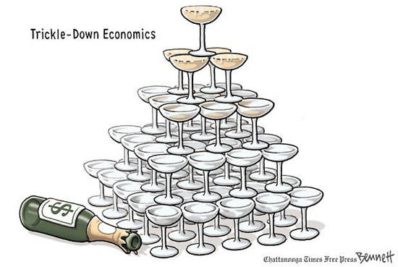
Iran-Contra Scandal | 1. The Iran-Contra scandal involved the US’ selling of what commodity?  2. In a separate incident from the Iranian Hostage Crisis, how did Reagan plan to convince Iranian captives to release 7 US hostages?  3. With the profits derived from the hostages-for-weapons scheme, what did Reagan’s administration plan to do?  4. What did both the sale of arms to Iran and the funding of the Nicaraguan contras violate?  5. In the end, was Reagan charged with any wrong-doing?
The Collapse of the Soviet Union  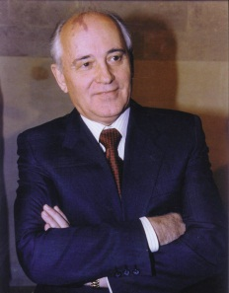 | 1. During Reagan’s administration, what major global event occurred?  2. What credit is Reagan given in the collapse of the Soviet Union?  3. In Reaganomics, Reagan decreased domestic spending, but increased spending in what sector of the economy?  4. Who was the leader of the Soviet Union at the time of its collapse?
Fall of the Berlin Wall  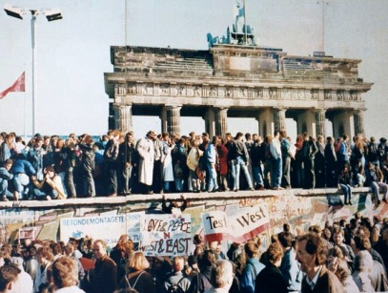 | 1. Reagan encouraged Gorbechev to end Soviet control over what part of its “empire”.  2. What country in Europe was one of the most important of these Soviet satellite nations?  3. What structure built in 1961 separated East Berlin (communist) from West Berlin (capitalist)?  4. In October 1989, what happened to the Berlin Wall?  5. The fall of the Berlin Wall signified the reunification of Germany. What does reunification mean?  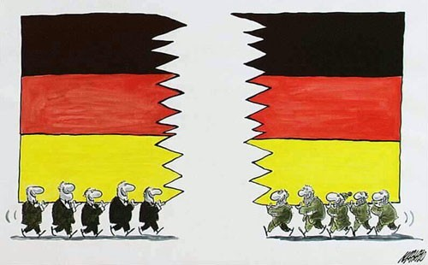
The Cold War Comes to an End | 1. On Christmas Day 1991, what action did Gorbechev take?  2. What happened to the political structure of the Soviet Union?  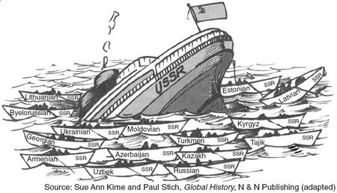  3. This collapse signaled the end of what 50 year “conflict”?

