The Progressive Era
SSUSH13 Evaluate efforts to reform American society and politics in the Progressive Era.
a. Describe the influence of muckrakers on affecting change by bringing attention to social problems.
b. Examine and explain the roles of women in reform movements.
c. Connect the decision of Plessy v. Ferguson to the expansion of Jim Crow laws and the formation of the NAACP.
d. Describe Progressive legislative actions including empowerment of the voter, labor laws, and the conservation movement.
Name, Event or Concept | Leading Questions
The Progressives  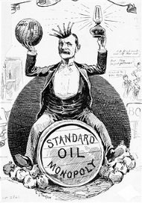 | 1. Who were the “Progressives” and what types of reforms did they want?  2. Whose help did they want in order to bring about these reforms?
Muckrakers  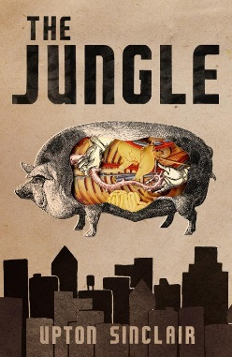 | 1. What was a “muckraker?”  2. Which muckraker wrote the book, The Jungle?  3. What was the book about?  4. What were people so upset about after reading the book?  5. What new laws did Congress pass because of the public outrage inspired by The Jungle?  6. Who wrote The History of Standard Oil?  7. What was the focus of that book?
Social Reforms  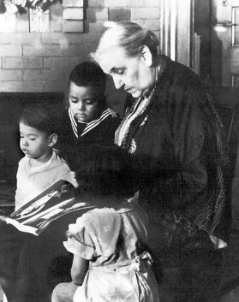  Jane Addams | 1. What was a “settlement house?”  2. Who was Jane Addams and what did she call the settlement house she opened in Chicago in 1889?  3. What three services did her house provide for poor women and children?  a.  b.  c.
Jacob Riis  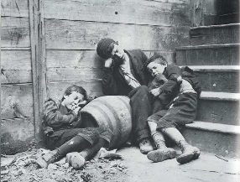 | 1. What book is Jacob Riis (pronounced Reece) famous for writing in 1890?  2. What was the book about?  3. Why did the book have such a strong impact on those who read it?
The South After Reconstruction  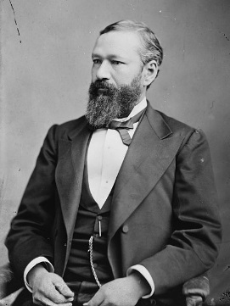  Homer Plessy | 1. What were the Jim Crow laws designed to do?  2. When were these laws enacted?  3. How did the Jim Crow laws get their name?  4. List three ways the South tried to deny African-Americans the right to vote?  a.  b.  c.  5. In 1896, which Supreme Court case upheld these Jim Crow laws?  6. What legal precedent was established by this case?
The NAACP  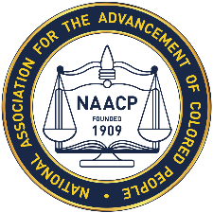 | 1. What do the letters NAACP stand for? When was it founded?  2. What is the goal of the group?  3. What terroristic crime was the group focused on in its early years?
Political Reforms  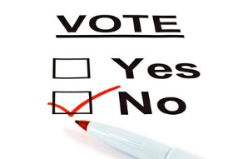 | 1. During this time, there was a lot of legislation passed that gave voters more power. List and define three of the new means of giving more power to the electorate.  a.  b.  c.  2. What did the 17th amendment do?
Theodore Roosevelt  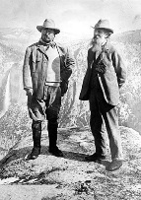 | 1. What national system did President Theodore Roosevelt help create that is still a benefit to Americans today?  2. What does that system do?

